ERRORS AND ERROR PROPAGATION

INTRODUCTION: Laboratory experiments involve taking measurements and using those measurements in an equation to calculate an experimental result. It is also necessary to know how to estimate the uncertainty, or error, in physical measurements and to know how to use those uncertainties to calculate the error in the experimental result.

TYPES OF EXPERIMENTAL ERRORS

Experimental errors can generally be classified into three types: personal, systematic, and random.

Personal Errors

These errors arise from personal bias of carelessness in reading an instrument, in recording data, or in calculations, and parallax in reading a meter. Of these, only parallax errors can be estimated and used in error propagation. Effort should be made to eliminate experimental errors.

(When looking at non-digital meter, there is a small distance between the needle and the scale. As a result, the reading will change as the observer’s eye position changes from side to side. This apparent change in reading, due to the change in position of the observer’s eye, is called parallax.)

Systematic Errors

Errors of this type result in measured values which are consistently to high or to low. Conditions which lead to systematic errors are as follows:

1. An improperly calibrated instrument such as a thermometer which consistently reads 99ºC in boiling water instead of 100ºC.

2. A meter, micrometer, vernier caliper, or other instrument which was not properly zeroed or for which the zero correction factor was not considered.

3. Theoretical errors due to a simplified mathematical model for the system which consistently gives a calculated value different from the calculated value predicted from a more accurate mathematical model.

Random Errors

Random errors result from unknown and unpredictable variations in experimental measurements. Possible sources of random errors are:
1. Observational-e.g. , errors when reading the scale of a measuring device to the smallest division.

2. Environmental- unpredictable fluctuations in readings beyond the experimenters control. Such errors can be determined statistically or can be estimated by the experimenter.

STATISTICAL DETERMINATION OF RANDOM ERRORS

When there are many measurements of the same quantity, the average or mean value is defined by 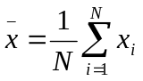 where  is the i^{th} measured value and N is the total number of measurements.

There are two ways to statistically calculate the uncertainty in the measured value. One method is to calculate the deviation from the mean or “mean deviation d”

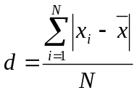
It is common to express the experimental value of the measurement as:

Measured value of x =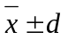

where d a statistical estimate of the uncertainty in the measured value. As can be observed, the mean deviation is a measure of the spread on the data.

Another method used to calculate the random error is by calculating the “standard deviation, (s.d.)”

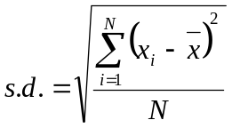
The measures value of x can then be expressed as:

Measured value of 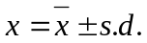

The statistical methods above will be used in selected lab exercises to follow such as “THE SIMPLE PENDELUM” and “MOMENT OF INERTIA” where several measurements of time are needed and an average or mean is calculated.

ESTIMATION OF RANDOM ERRORS

An easier method to determine random error is to estimate the random error by utilizing the accuracy of the instrument and the judgment of the experimenter. The error in a given instrument is determined by the smallest division on that instrument or “least count.” For example, the smallest division on a meter stick is 1mm or 0.1cm. This is the least count for the meter stick. In most measurements the smallest division represents the rightmost digit in the value of that measurement and the estimated error is the measurement is the least count. For example, a measure value may be 78.2cm0.1cm.

Sometimes a measurement may be made with an estimated error less than the least count. For example, an experimenter may estimate reading on a meter stick as 78.25cm by noting that the reading was about half way between 78.2cm and 78.3cm. The experimenter may represent the value as 78.25cm0.05cm. Keep in mind that rightmost digit must be estimated by the experimenter and is thus doubtful.

Sometimes the estimated error is larger than the least count. For example, when measuring the distance between the two spots below, the experimenter would need to estimate where the center of each spot would be located. The error in the measured distance would be larger than the least count and the amount of the estimated error would be up to the judgment of the experimenter.

Note how much the error estimates depend on the judgment of the experimenter. There may be errors in judgment; however, to avoid stating a result more accurately than you probably measured it, one should try to avoid being too conservative in estimating errors.

ERROR PROPAGATION

PARTIAL DERIVITIVES

Before we can perform error propagation calculations, we must know how to take what are called “partial derivatives” of a function with many variables. Some may already know how to do this; you can help the others.

Suppose we have a function f where f=f(x,y,z). The partial derivative of f with respect to x is found by taking the ordinary derivative while treating y and z as constants. The notation for this derivative is 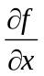. Likewise, the partial derivative of f with respect to y is found by taking the ordinary derivative while treating x and z as constants and is written as 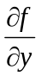 and the partial derivative of f with respect to z is found by taking the ordinary derivative while treating x and y as constants and is written as 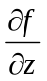.

As an example, let 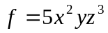. Then 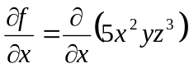 = 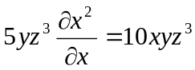

Convince yourself that 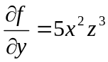 and that 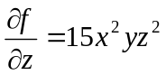.

ABSOLUTE AND RELATIVE ERRORS

Absolute Error: When an error is estimated in a measured value of x it will be designated as 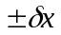(delta x). 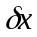has the same units as x and is called the absolute error in x. For example, if
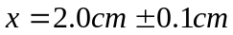, the absolute error is 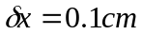.

Relative Error: The ratio of the absolute error to the measured value x, 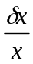, is called the relative error. It is usually represented as a percent. For example, the relative error in the above example is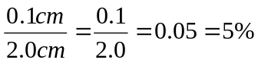

(note, there are times when it is necessary to from relative error back to absolute error: 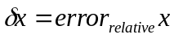)

COMPUTATION OF ERROR

For a function 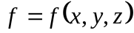, the absolute error in f,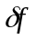, is defined as:

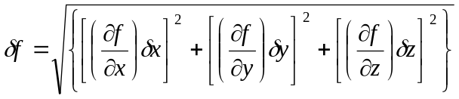

The relative error in f would thus be 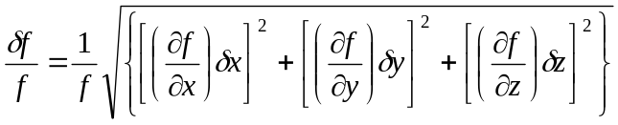

EXAMPLE

Using the function we used as an example for partial derivatives, we would have

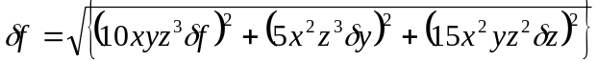

thus 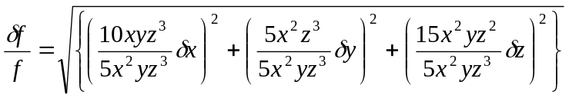 which when simplified becomes

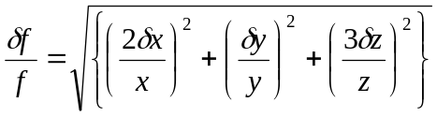

Note that the quantities in the parentheses are just the percent errors multiplied by the exponent for that particular variable.

Suppose we have the experimental values for x, y, and z as:

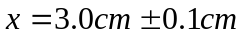,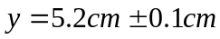, and 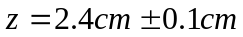.
We would thus have the percent error in f as: 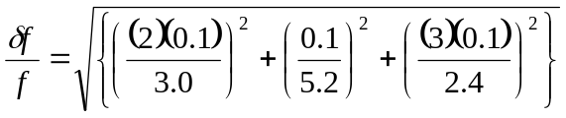= 0.143 ≈15%

Note that the % error is rounded up to the nearest whole number. Since it is just an estimate, we can not justify more accuracy in the error.

ANOTHER EXAMPLE

Suppose 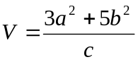 where 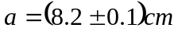, 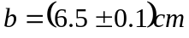, and 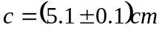

Thus 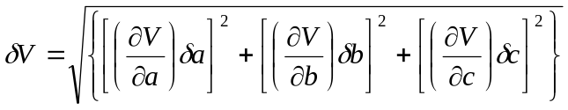

where 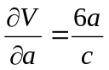,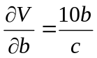, and 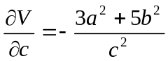; or,

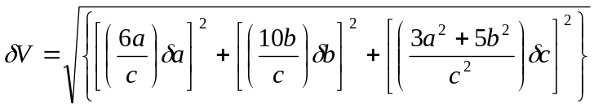
Notice that the negative sign in 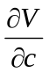 does not matter since it is squared.

Now 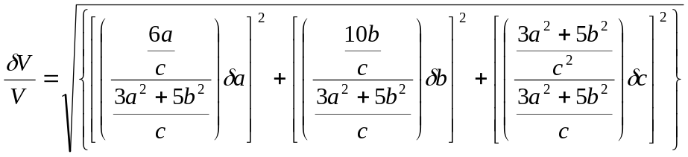

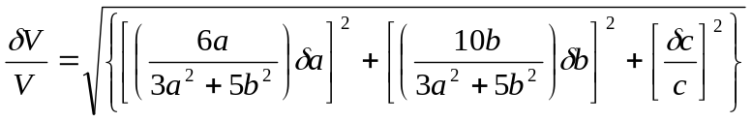

Or,

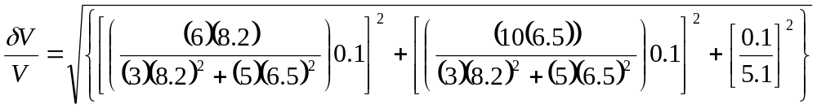=5.5%
≈6%

The final results would be given as 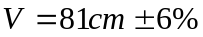

PERCENT DISCREPANCY

Once an experimental value and its percent error are calculated, the percent discrepancy is defined as:

percent discrepancy in X= 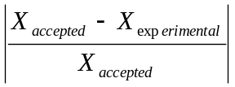

There will be agreement between the accepted value and the experimental value if the percent discrepancy is less than the predicted percent error in the experimental value as determined by error propagation. In other words, the experimental value is within the margin of error. This should be addressed in your conclusion.

If there is not agreement, some sources of error may be present which may not have been accounted for and some reasonable explanation should be included in the conclusion of your report.
ERROR PROPAGATION EXERCISES

Determine the calculated value using the given values in the given equations. Be sure to include the units in your answer. Using the error propagation method described above, calculate the percent error in the calculated value. For this exercise, your percent error is to be given to two significant figures.

Hand in this answer sheet. Work the problems neatly on scratch paper and staple your work to this sheet.

1. A=xy, 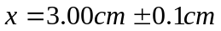, 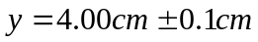 ______________________

2. f=x+y, for x and y given in problem # 1 ______________________

3. f=x-y, for x and y given in problem # 1 ______________________

4. z=3x+2y, for x and y given in problem # 1 ______________________

5. 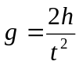 for 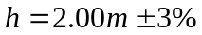, 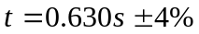 ______________________

6. 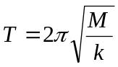, 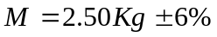, 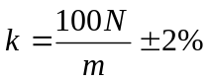 ______________________

7. 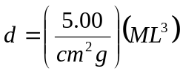, 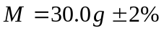, 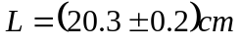 ___________________

8. 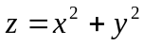, 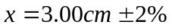, 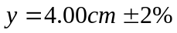 ______________________

9. 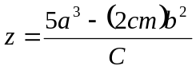,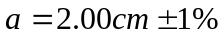, 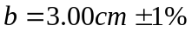, 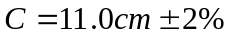
______________________

10.  

